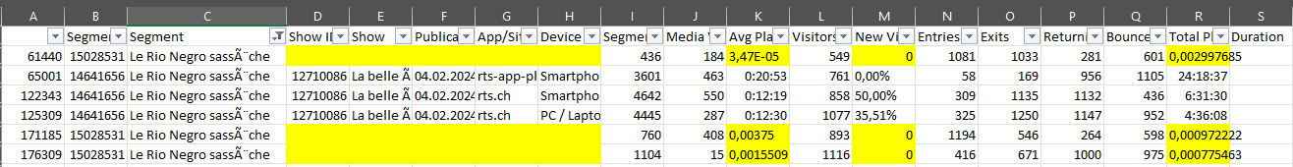Missing values explanation: representing 0.04% of the dataset + having formatting issues + 0 New Viewers

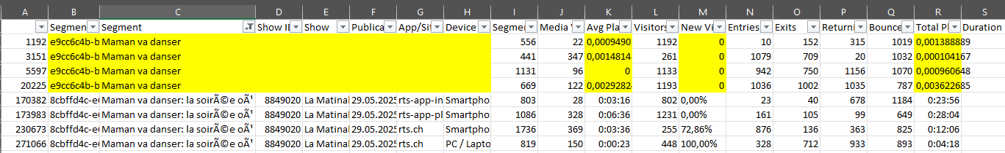

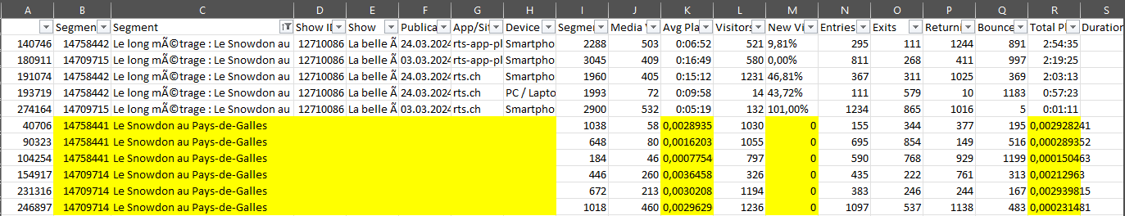

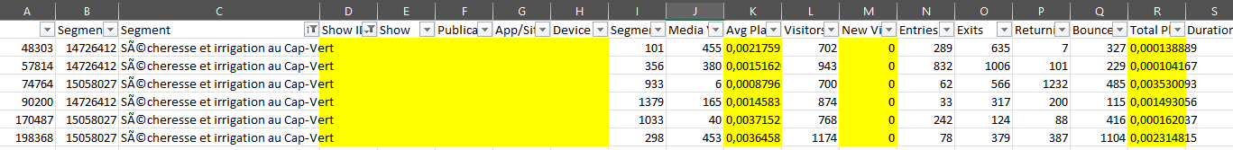

Example:   
« Le Rio Negro s'assèche » with different ‘Segment ID’ & ‘Segment’ would not have helped for the Show ID and Show  
“Maman va danser” could have been duplicated rows

Duplicated tag explanation

* In order to avoid duplicated row with different ‘Primary Theme’ > keeping the first

